I am using these notes for my understanding and stuff, I’ve used ai to help give examples and concepts where I hadn’t written the code and didn’t want to write the notes extensively by myself

.extend() to add the separated elements of a list to another list
- .append() to add an individual element “
# Using .append() numbers = [1, 2] numbers.append([3, 4]) print(numbers) # Output: [1, 2, [3, 4]] -> The list got nested
# Using .extend() numbers = [1, 2] numbers.extend([3, 4]) print(numbers) # Output: [1, 2, 3, 4] -> The lists were merged
- .insert(index, element)
fruits = ["apple", "banana", "cherry"]
# Insert "orange" at index 1 (the second position)
fruits.insert(1, "orange")
print(fruits)
# Output: ['apple', 'orange', 'banana', 'cherry']
- string.count(substring, start, end)

text = "Python is fun, and Python is powerful."

# Count a specific word
print(text.count("Python")) # Output: 2

# Case sensitivity check
print(text.count("python")) # Output: 0 (lowercase 'p')

# Counting with a specific range (indices 0 to 15)
print(text.count("Python", 0, 15)) # Output: 1

numbers = [1, 4, 2, 9, 7, 8, 9, 3, 1]
fruits = ["apple", "banana", "cherry", "apple"]

# Count an integer in a list
print(numbers.count(9)) # Output: 2

# Count a string in a list
print(fruits.count("apple")) # Output: 2

# Nested structures look for exact matches
nested_list = [[1, 2], 3, [1, 2], 4]
print(nested_list.count([1, 2])) # Output: 2
- .index() sequence.index(element, start, end)

fruits = ['apple', 'banana', 'cherry', 'banana']

# Find the position of 'cherry'
print(fruits.index('cherry'))
# Output: 2

# Finding 'banana' only returns its first occurrence
print(fruits.index('banana'))
# Output: 1

- Try and except
try:
result = 10 / 0
except ZeroDivisionError:
result = 0

print(result)
# Output: 0

- file_object = open("filename.txt", "mode")
# Open to write (creates file)
file = open("notes.txt", "w")
file.write("Hello")
file.close()

# Open to append (adds to file)
file = open("notes.txt", "a")
file.write(" World")
file.close()

# Open for both reading and writing
file = open("data.txt", "r+")
print(file.read())
file.write("New update")
file.close()

# Open an image file in binary mode
image = open("photo.jpg", "rb")
data = image.read()
image.close()

file = open("document.txt", "r")

# Read everything at once
print(file.read())

# Or read lines as a list
lines = file.readlines()
file.close()
these lines will be output as a list of strings
file = open("output.txt", "w+")
file.write("Line 1\nLine 2")
#
file.seek(0) # Move cursor to start to read what we just wrote
print(file.read())

#file.close() # Safely close the file

#with function
with open("story.txt", "r") as file:
content = file.read()
# File is automatically closed here
with open("log.txt", "w") as file:
file.write("Log entry success")
# File is automatically closed here

Numpy:

.size -> total size
.ndim -> dimension
.shape -> (r,c)
.itemsize -> number of bytes of int64-> 8
.nbytes -> total bytes

Get a element
a[r,c]

here : means the whole thing combined

get a row
a[r,:]

get a column
a[:,c]

z[start:stop:step]
so z[::-1] reverses the whole thing it assumes I want to move back by one step so it reverses

np.zeros((2,3,3))

array([[[0., 0., 0.],
[0., 0., 0.],
[0., 0., 0.]],

[[0., 0., 0.],
[0., 0., 0.],
[0., 0., 0.]]])

np.ones((2,3,3,3))
np.full((3,2),2)
gives me a 3x2 array of elements 2
np.random.rand(4,2)
array([[0.93736498, 0.89371751],
[0.59154919, 0.82610349],
[0.74357891, 0.30813804],
[0.44307204, 0.37572681]])
np.random.randint(-8,7,size=(3,3))
array([[-3, -7, 4],
[-3, -7, -6],
[-4, -6, -8]])
np.identity(4)
array([[1., 0., 0., 0.],
[0., 1., 0., 0.],
[0., 0., 1., 0.],
[0., 0., 0., 1.]])
a=np.array([1,2,3])
r=np.repeat(a,3)
print(r)
[1 1 1 2 2 2 3 3 3]
a=np.array([[1,2,3]])
r=np.repeat(a,3,axis=0)
print(r)
[[1 2 3]
[1 2 3]
[1 2 3]]

Counting from the end: In Python and NumPy, negative indices count backward from the end of an array. Therefore, -1 always refers to the very last element (or the last row/column in a 2D array).
a=np.ones((5,5))
z=np.zeros((3,3))
z[1,1]=9
a[1:-1,1:-1]=z
print(a)
[[1. 1. 1. 1. 1.]
[1. 0. 0. 0. 1.]
[1. 0. 9. 0. 1.]
[1. 0. 0. 0. 1.]
[1. 1. 1. 1. 1.]]

Can perform direct math of elements of two arrays
a+b
a+b adds the elements etc.

np.matmul(a,b) multiplies matrices
np.linalg.det(a) finds the determinant

np.min(a)
np.max(a,axis=1) finds max elements in each row

# A 4D array visual representation
[ <-- axis=0 (Outermost: e.g., compares 3d arrays by position image 1 to image 2)
[ <-- axis=1 (e.g., compares 2d arrays by position)
[ <-- axis=2 (e.g., compares 1d arrays or goes down the rows of the image)
[1, 2] <-- axis=3 (Innermost: compares elements or goes across the columns/pixels)
]
]
]
a.reshape(r,c) works as long as total same number of elements
v1,v2
v=np.vstack([v1,v2])
v=np.hstack([v1,v2])

Load data from file
a=np.genfromtxt(‘data.txt’,delimiter=’,’) separates using commas
a = filedata.astype(‘int32’) changes datatype

a>50
gives Boolean masking i.e. places a true where it is true and….

# 1. Create the arrays (they must be the exact same size)
scores = np.array([45, 72, 30, 88, 91])
names = np.array(["Alice", "Bob", "Charlie", "David", "Eve"])

# 2. Create the boolean mask based on the scores
# This creates a hidden array of True/False values: [False, True, False, True, True]
passing_mask = scores > 50

# 3. Apply the mask to the names array
# NumPy matches the True/False values to the names by their index position
passing_students = names[passing_mask]

# 4. View the results
print("All students:", names)
print("All scores:", scores)
print("Students who passed:", passing_students)

# You can also do it in one single line without saving the mask as a variable:
# print(names[scores > 50])

Advanced indexing examples
a[[0,1,2,3],[1,2,3,4]] gives me the elements 0,1 1,2 2,3 3,4
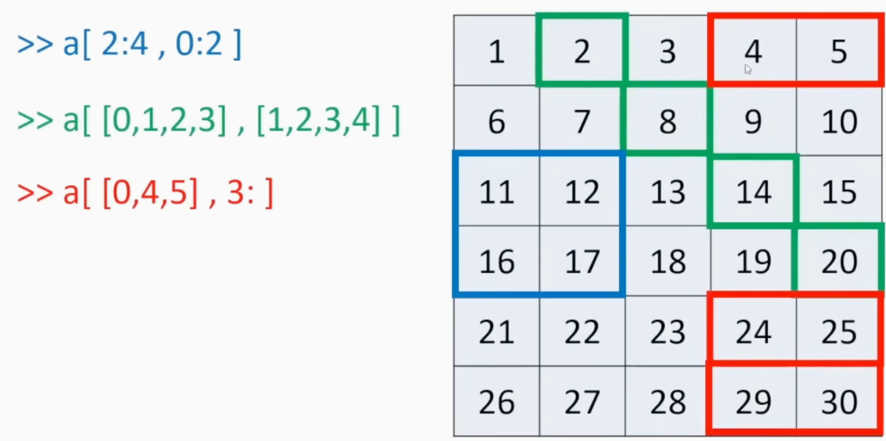

100 NumPy problems notes:
17. • Math with NaN is always NaN: Because np.nan (Not a Number) is undefined, any arithmetic with it (like 0 * np.nan or np.nan - np.nan) just equals nan.
• NaN never equals NaN: np.nan == np.nan is False. An undefined value cannot definitively equal another undefined value.
• You can't compare NaN: np.inf > np.nan is False. All logical comparisons (>, <, >=) against nan are always False.
• The Set Exception: np.nan in set([np.nan]) is True. Python checks if they are the exact same object in memory first, bypassing the == rule.
• Floating-Point Math is Imprecise: 0.3 == 3 * 0.1 is False. Because of how computers do binary math, 3 * 0.1 actually equals 0.30000000000000004. (Tip: use np.isclose() to compare floats).
18. np.diag works like takes a 1d array and gives us a diagonal matrix with k=0, k=-1 gives 1 diagonal below and so on.
a = np.diag([1,2,3,4],k=-1)
20. gives index of n+1th element
print(np.unravel_index(99,(6,7,8)))

21. np.tile
# Repeat the list [1, 2] three times
a = np.tile([1, 2], 3)
print(a)
# Output: [1 2 1 2 1 2]
base_tile = np.array([[0, 1],
[1, 0]])

# Repeat the 2x2 base_tile 3 times downwards (rows) and 2 times across (columns)
grid = np.tile(base_tile, (3, 2))
print(grid)
22. Normalisation
normalizing a matrix means mathematically adjusting its values so they fall onto a common, standardized scale.
(Z - np.mean(Z)) / np.std(Z) is doing:
$Z_{normalized}=\frac{X-μ}{σ}$

23. Custom datatype
color = np.dtype([("r", np.ubyte),
("g", np.ubyte),
("b", np.ubyte),
("a", np.ubyte)])

ubyte stands for "unsigned byte".
Here is what that means broken down:
- Byte: This is a small unit of computer memory (8 bits long). It can hold exactly 256 different possible values.
- Unsigned: This tells the computer that the number cannot have a negative sign. It only stores zero and positive numbers. (A "signed" byte, on the other hand, splits those 256 values to hold numbers from -128 to 127).
In digital graphics, each of these color channels is standardly represented by a number from 0 to 255. For example, solid red is (255, 0, 0, 255)
25. we can put conditions inside the index space which masks a Boolean value and only implements operation on the true elemetns
26. from numpy import * -> * acts as a wildcard that translates to "everything". When you write from numpy import *, you are telling Python to grab every single function, variable, and tool inside the NumPy library and dump them directly into your current workspace without needing to type np. first.
print(sum(range(5), -1)) Now, this is using NumPy's sum() function.
- NumPy's sum takes different arguments. The first is still the array, but the second positional argument is the axis you want to sum along, not a starting value!
- axis=-1 just means "sum along the last axis". Since range(5) is a flat 1D list, it just sums all the numbers normally.
- So, it calculates: 0 + 1 + 2 + 3 + 4 = 10
27. Problem 27 tests how standard Python operators interact with NumPy arrays. Assuming Z is an integer array (like Z = np.array([1, 2, 3])), here is a breakdown of which expressions are legal and why:

1. Z ** Z (Legal)

- What it does: Element-wise exponentiation. It raises each element in Z to the power of itself.

- Example: If Z has [1, 2, 3], this calculates $1^{1},2^{2},3^{3}$, resulting in [1, 4, 27].

2. 2 << Z >> 2 (Legal)

- What it does: These are bitwise shift operators. It takes the integer 2, shifts its binary representation to the left by the amount specified in Z, and then shifts that result back to the right by 2. It works perfectly fine with integer arrays.
- What are bitwise shift operators
left shift (<<) and right shift (>>) operators. These literally slide the binary bits to the left or right, filling in the empty spaces with zeros.
- Left Shift (<<): Sliding bits to the left essentially multiplies the number by 2 for every shift.
  - 2 << 1 (Shift the number 2 left by 1 place)
  - Binary 0010 becomes 0100 (which is the number 4).
- Right Shift (>>): Sliding bits to the right essentially divides the number by 2 (rounding down) for every shift.
  - 4 >> 1 (Shift the number 4 right by 1 place)
  - Binary 0100 becomes 0010 (which is the number 2).

3. Z <- Z (Legal)

- What it does: This looks like an arrow, but it is actually two separate operators: < (less than) and - (negative). Python reads this as Z < (-Z). It compares each element to its negative counterpart and returns an array of True/False values.

4. 1j * Z (Legal)

- What it does: In Python, 1j represents the imaginary number $i$. This multiplies every element in Z by 1j, converting your integer array into an array of complex numbers (e.g., [0.+1.j, 0.+2.j, 0.+3.j]).

5. Z / 1 / 1 (Legal)

- What it does: Standard element-wise division. It divides every element by 1, and then divides the result by 1 again. (Note: in Python 3, this will convert your integer array into a float array).

6. Z < Z > Z (ILLEGAL)

- Why it breaks: Python tries to evaluate chained comparisons like this as (Z < Z) and (Z > Z).

- The first part, Z < Z, creates an array of Booleans (e.g., [False, False, False]). When Python's underlying and operator tries to evaluate that entire array to see if it is True or False as a whole, it panics and throws a ValueError. NumPy forces you to use .any() or .all() if you want to evaluate an entire array's truth value!

So, to answer the question: All of them are legal except the last one (Z < Z > Z).

29. np.copysign(..., Z): Finally, look at the original array Z and paste the original positive or negative signs back onto your new whole numbers (e.g., the 2.0 gets its minus sign back and becomes -2.0).

Panda->
1. Creating a DataFrame
- Imported Pandas using import pandas as pd
- Learned about DataFrames
- Created a DataFrame using a dictionary
2. Inspecting a DataFrame
- head() — displays the first 5 rows
- shape — gives the number of rows and columns
- columns — gives the column names
- info() — provides information about the DataFrame
- describe() — provides statistical information
3. Selecting Data
- Selected individual columns using df["column"]
- Used iloc to access rows using their numerical positions
- Used iloc with column selection to access specific values
4. Filtering Data
- Used conditions to filter rows
- Used > and >= for numerical conditions
- Used == for matching values
- Used & for AND conditions
- Used | for OR conditions
5. Missing Values
- Used isnull() to identify missing values
- Used isnull().sum() to count missing values
- Learned dropna() for removing missing values
- Learned fillna() for replacing missing values
6. Sorting
- Used sort_values() to sort rows
- Learned ascending and descending sorting using ascending=True/False
7. Basic Statistics
- mean()
- median()
- min()
- max()
- sum()
- count()
- describe()
8. Grouping Data
- Used groupby() to divide data into groups based on a column
- Applied functions such as mean(), sum(), count(), min() and max() to groups
9. Counting Values
- Used value_counts() to count occurrences of unique values in a column
Matplotlib:

iport matplotlib.pyplot as plt

basic plotting of lines
plt.plot(x,y)

bar graph
plt.bar(categories, values)

histogram
plt.hist(data,bins=5)
used to show distribution of numerical data

plt.scatter(x, y)
used to see relation between numerical variables

labeling
plt.title(“learning”)
plt.xlabel(“x-axis”)
plt.ylabel(“Y-axis”)

show graph
plt.show()

legend
plt.plot(x, y1, label="Data 1")
plt.plot(x, y2, label="Data 2")
plt.legend()

